See page source

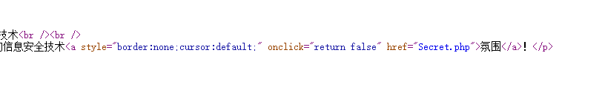

Goto Secret.php



Using burp suite

Add

Referer: <https://Sycsecret.buuoj.cn>



Add

User-Agent: "Syclover"



Using X-Forwarded-for construct fake src_ip as 127.0.0.1 or localhost

X-Forwarded-for: 127.0.0.1

Get flag



flag{19b46090-e1d1-4af0-9494-3f0d1ef54be1}

All code is

Referer: <https://Sycsecret.buuoj.cn>

User-Agent: "Syclover"

X-Forwarded-for: 127.0.0.1

